

**Report on Trip Boss**

# Submitted By: Submitted To:

## Divyansh Jain Mr. Lovish Sir

G -21

## 2110992203

**Department of Computer Science & Engineering Chitkara University Institute of Engineering & Technology,**

**Rajpura, Punjab**

Report on Trip Boss

My project is Based on Tour, travel and Photography

Trip Boss

Homepage:

The homepage of our expansive travel website is carefully designed to immerse visitors in a world of exploration and adventure. Our Featured Places section serves as an enticing visual introduction to our most captivating and sought-after destinations. These featured places are carefully chosen to ignite the wanderlust of travelers, beckoning them to embark on their dream vacations.

What We Offer:

At the heart of our travel website is our commitment to delivering extraordinary travel experiences. When you choose us as your travel partner, you can expect:

1. Luxurious Accommodations: We understand that where you stay during your travels is crucial. We are dedicated to providing you with a selection of luxurious accommodations that promise comfort, opulence, and unforgettable moments. Our range of luxury hotels and resorts reflects our unwavering commitment to offering the very best in hospitality.

2. Competitive Pricing: We firmly believe that extraordinary travel experiences should not come with an extraordinary cost. Our competitive pricing ensures that you receive the best value for your money. We believe that you should travel in style without breaking the bank. With us, affordability and luxury go hand in hand.

3. Expert Travel Guides: Our team of seasoned travel experts is your companions throughout your journey. They are here to assist and guide you at every step, ensuring that your travel experience is seamless and memorable. Whether you need destination recommendations, insider tips, or assistance with planning, our travel guides are dedicated to making your journey truly exceptional.

Testimonials:

The true measure of our success is the experiences of our customers. In our Testimonials section, you'll discover a treasure trove of candid and unfiltered testimonials from travelers who have embarked on incredible journeys with us. These testimonials are more than just words; they are a testament to the quality of our services and our unwavering commitment to fulfilling promises. We hold the trust our customers place in us in the highest regard and eagerly anticipate you joining our community of satisfied and inspired travelers.

Gallery:

Page 2 provides a visual odyssey, taking you on a captivating tour of the remarkable destinations we offer. Our Gallery is a compilation of visually stunning images from famous places where we provide our services. These images transcend mere photographs; they are windows to the world, offering a tantalizing glimpse of the beauty and diversity of these destinations. Alongside these images, you'll encounter reviews and feedback from fellow travelers who have explored these destinations. These genuine accounts provide valuable insights and serve as inspiration for your future journeys.

Blog Page:

Page 3 is our Blog page, a dynamic platform for both us and our customers to share their travel stories, insights, and tips on a wide range of topics. We warmly invite you to contribute your experiences and knowledge, transforming this page into a treasure trove of travel inspiration and information. Whether it's travel diaries, destination guides, or packing tips, this blog is a vibrant hub of travel enthusiasts, where the joys and challenges of travel are celebrated and shared.

Our Journey:

Page 4 provides an insightful look into our history and unwavering dedication. With 15 years of experience in the travel industry, our journey began with a fervent passion for exploration, and this passion continues to drive our commitment to providing extraordinary travel experiences. Over the years, we've organized an impressive 1220 photoshoots, visited 450 stunning beaches, conquered 84 majestic mountains, and hosted 120 unforgettable cruises. These figures represent our rich experience and the incredible moments we've created for travelers. Our team is devoted to ensuring that your travel experiences are not just exceptional but also memorable from the beginning to the end.

Privacy Policy:

We take your privacy seriously. Our Privacy Policy section explains how we collect, use, and protect your personal information. It ensures that your data is handled with care and in compliance with relevant privacy regulations. We prioritize the confidentiality and security of your personal data.

Page 5:

Our Contact Us section, is your direct connection to our team of travel experts. Here, you'll find comprehensive contact information, including our phone number and email address. We've made it as easy as possible for you to reach out with inquiries, requests, or simply to connect with our team. We're here to assist you in planning your next adventure and are eager to provide the support and information you need for your travels.

With this comprehensive website, featuring Featured Places, a detailed description of what we offer, a captivating gallery of famous destinations with reviews, a dynamic blog for sharing travel experiences and insights, an insightful journey section highlighting our experience, a robust Privacy Policy, and a seamless Contact Us page, your visitors will embark on a comprehensive and inspiring travel journey. Your commitment to providing luxurious accommodations, competitive pricing, and expert travel guides is certain to resonate with travelers seeking extraordinary adventures.

But that’s not it, when you are travelling you certainly want to explore new and luxurious hotel we got you covered, when you click on luxurious hotel on page 1, you will be redirected to hotel page which Is located all around the globe to serve your lavish needs.

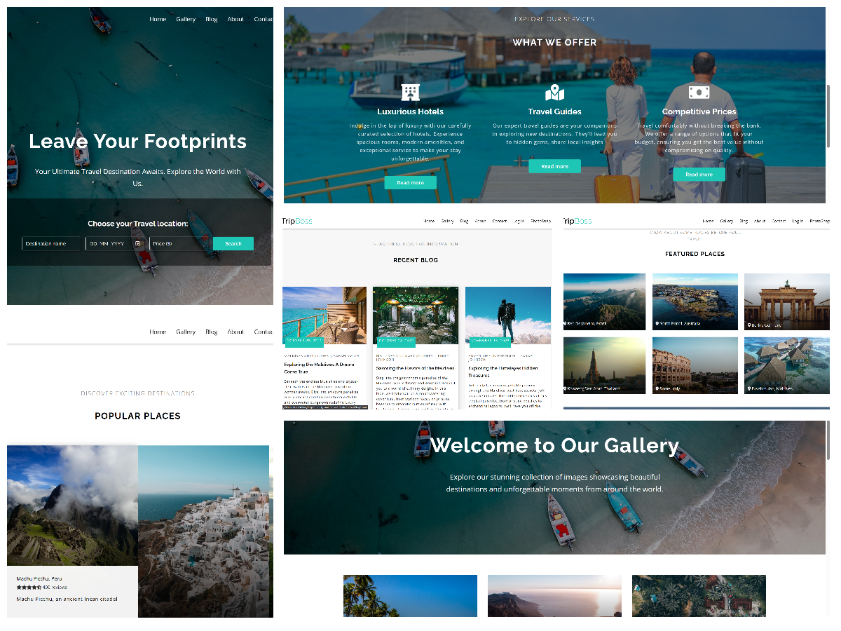

Hotel BeachSide

Page 1:

Header:

Imagine you've just entered the lobby of a luxurious beachfront hotel. The website's header serves as your virtual concierge, offering an array of services and information right at your fingertips. Here's a closer look at each component:

- Logo (BS): Just like an elegant hotel's emblem, our logo BS, short for Beach Side, proudly represents our brand.

- Menu Items: These are like the well-dressed attendants at the concierge desk, each ready to assist you with a specific request.

- Home: It's akin to the front desk, welcoming you to your virtual stay.

- About: This is like the hotel's historian, sharing the rich story and background of our establishment.

- Gallery: Think of this as the hotel's art curator, displaying a captivating visual tour.

- Contact: Much like the hotel's reservations team, it's here to help with inquiries or bookings.

- Log In: If you've stayed with us before, this is your VIP access to your personal account.

- Sign Up: For new guests, it's like receiving your exclusive membership to our hotel.

- Travel: This is your ticket to a world of travel services and adventures we offer.

Homepage:

The homepage is like our opulent lobby's grand entrance. Picture it as a welcoming carpet leading you into our digital world of hospitality. The key features include:

Showcase:

This is the heart of the hotel lobby, a grand chandelier-lit space where you're greeted with a warm message. The inviting background image is like the stunning view you'd encounter upon stepping into our real hotel.

About Our Hotel:

This section is equivalent to sitting down in our elegant lounge, where the hotel's history and charm are shared with you:

- Home Info Section: Imagine a courteous host telling you the story of our hotel. It's designed to make you feel at home. The Book Room button is like a helpful staff member offering to assist you in reserving your accommodation.

Hotel Features:

Now picture strolling through the hotel's corridors and discovering its unique features. This part serves the same purpose, emphasizing the exclusive amenities we offer:

- Features Section: Each box is like a service desk highlighting what makes your stay with us extraordinary.

- Great Location: It's like a well-informed concierge explaining how our location is perfect for your holiday.

- Free Meals: Similar to a staff member mentioning the complimentary meals we provide.

- Fitness Room: Think of this as the personal trainer showcasing our well-equipped gym for your daily workouts.

Footer:

Finally, the footer is the exit area, where the hotel's gatekeepers provide some important information:

- Footer Information: This is akin to a sign at the hotel's entrance or exit. It includes the copyright notice, ensuring that our hotel's name and content are protected.

In summary, the Hotel Beach Side website is a virtual representation of a luxurious, welcoming hotel. The header is your concierge, the homepage is the grand entrance, About Our Hotel is the lounge with history, Hotel Features are the unique amenities, and the footer is the exit area with essential information. Just like a real hotel stay, we aim to make your virtual experience informative and enjoyable.

Page 2:

Header and Navigation Menu:

The About page of Hotel BeachSide opens with a stylish header that serves as the gateway to exploring the essence of our establishment. Think of it as the grand entrance to our luxurious beachfront hotel.

- Navigation Menu: The navigation menu, like the concierge's desk, is your guide to all the amenities and features our hotel offers. It provides easy access to various sections of our website. You can smoothly navigate to different areas, such as Home, About, Gallery, Contact, Log In, Sign Up, and Travel. These sections are like the doors leading to different aspects of your virtual stay with us.

About Hotel BeachSide:

As you step further into our About section, you're welcomed into the heart of HOTEL BeachSide, as if our friendly hotel manager has personally greeted you in the lobby. Here's what you'll discover:

- Introduction: The About-Info Section offers a warm introduction to HOTEL BeachSide. Imagine our manager explaining that our hotel is uniquely positioned right where the golden sands meet the gentle waves. It's an exceptional beachfront experience that masterfully combines relaxation, adventure, and the creation of unforgettable memories.

- Panoramic Views: Each room in our hotel boasts panoramic views of the glittering ocean, ensuring that the beauty of nature is just a glance away. Whether you're sipping your morning coffee or stargazing at night, the beach becomes your ever-changing backdrop. It's as if you've just entered one of our ocean-view rooms and are gazing out of the window, with the waves lapping at the shore.

What Our Guests Say:

As you continue your journey through the About page, you'll find a section dedicated to the experiences and voices of our esteemed past guests. Think of it as reading the heartfelt messages and notes in the guestbook in our lobby:

- Testimonials Section: This part of the page allows you to hear the voices and stories of our previous guests. You'll come across two heartwarming testimonials, one from Samantha and another from Vinshu. They share their delightful experiences of staying at Hotel BeachSide. It's akin to striking up a conversation with fellow travelers who've already enjoyed their stay, like meeting guests in the lobby lounge and hearing their travel stories.

Footer:

As you prepare to leave the About page, you reach the footer, which serves as the virtual exit area of our hotel. Here's what you'll find:

- Footer Information: The footer is much like the exit sign in a physical hotel. It provides essential information, including a copyright notice to protect our website content.

In summary, the About page of Hotel BeachSide is the virtual equivalent of the elegant lobby of our beachfront hotel. It's the place where we cordially welcome you and provide an overview of what you can expect during your stay with us. As you explore this page, you'll get a glimpse of the beautiful beachfront scenery, and you'll have the opportunity to hear from previous guests, much like you would in a real hotel lobby. Our goal is to make your virtual experience informative, enjoyable, and just as welcoming as a real hotel stay.

Page 3:

A Glimpse of Paradise:

Our Gallery Page is a sneak peek into the paradise that awaits you at Hotel BeachSide. Whether you're a past guest reminiscing about your stay or a potential guest considering a visit, this page encapsulates the natural beauty and ambiance that defines our beachfront retreat. In conclusion, our Gallery Page is your virtual window to the enchanting world of Hotel BeachSide. It's a place where the visual allure of our beachfront property is showcased, and we hope it stirs your curiosity and inspires you to experience our hotel in person. We remain committed to making your digital exploration of our services as seamless and engaging as an actual stay with us.

Page 4:

1. Contact Form:

To foster a direct line of communication, we have included a user-friendly contact form. This form allows you to reach out to us effortlessly. You can provide your name, email, and a message detailing your inquiries or feedback. We aim to provide a personal touch akin to speaking with our front desk staff.

2. Location and Contact Information:

Further down the page, you will find our contact information. It includes:

- Location: 50 Main Market, Chakrata. We believe in transparency and making it easy for you to find us.

- Phone Number: Contact us at 800005000 for any immediate assistance. Our team is here to provide you with the support you need.

- Email Address: For written inquiries, you can reach us at hotel. BeachSide@gmail.com. We are dedicated to responding to your emails promptly.

3. Commitment to Communication:

At Hotel, we emphasize the importance of clear and open communication. Our Contact Page reflects our dedication to ensuring that you can reach us effortlessly. We're ready to assist you with booking inquiries, reservations, and any other questions you might have. Think of it as our virtual concierge service, always at your disposal.

In conclusion, our Contact Page is your gateway to connecting with Hotel BeachSide. Whether you want to make a reservation, provide feedback, or simply inquire about our services, we are here to assist. We prioritize excellent customer service, and our Contact Page is a testament to our commitment.

Page 5:

On Home page when you click on Rooms it redirect you to a page

I am pleased to present an overview of our room showcase at River Side Hotel, where we aim to provide a preview of the exceptional accommodations we offer to our guests.

1. Room Selection:

Our room showcase focuses on presenting our rooms to you. We believe that choosing the perfect room is an essential part of your experience. Here's a glimpse of our featured rooms:

Room 1: Couple Room

- Description: A comfortable room designed for couples.

- Price: ₹2000

- Book Now: This room offers an enticing deal for couples who seek comfort and affordability.

Room 2: Deluxe Room

- Description: A spacious and luxurious room.

- Price: ₹5000

- Book Now: Perfect for those looking for a more indulgent stay with added space and amenities.

Room 3: Executive Suite

- Description: An executive suite with a separate living area.

- Price: ₹7000

- Book Now: Ideal for business travelers or anyone who wants extra space and luxury.

Room 4: Presidential Suite

- Description: The epitome of luxury and extravagance.

- Price: ₹10000

- Book Now: Our most luxurious and spacious suite, perfect for a truly grand experience.

2. Room Card Details:

Each room card includes an image of the room, a description, pricing, and a Book Now button. We want you to have a clear understanding of what each room offers. The prices cater to different preferences and budgets.

3. Call to Action:

To encourage action, we've included a Check All Rooms button at the end of the showcase. This allows you to explore all our room offerings in more detail, ensuring you find the perfect room for your stay.

In conclusion, our Room Showcase is designed to give you a glimpse of the exceptional accommodations at River Side Hotel. Whether you seek a cozy room for a romantic getaway or a spacious suite for a more indulgent experience, we have options to suit your needs. We believe in offering variety without compromising on quality.

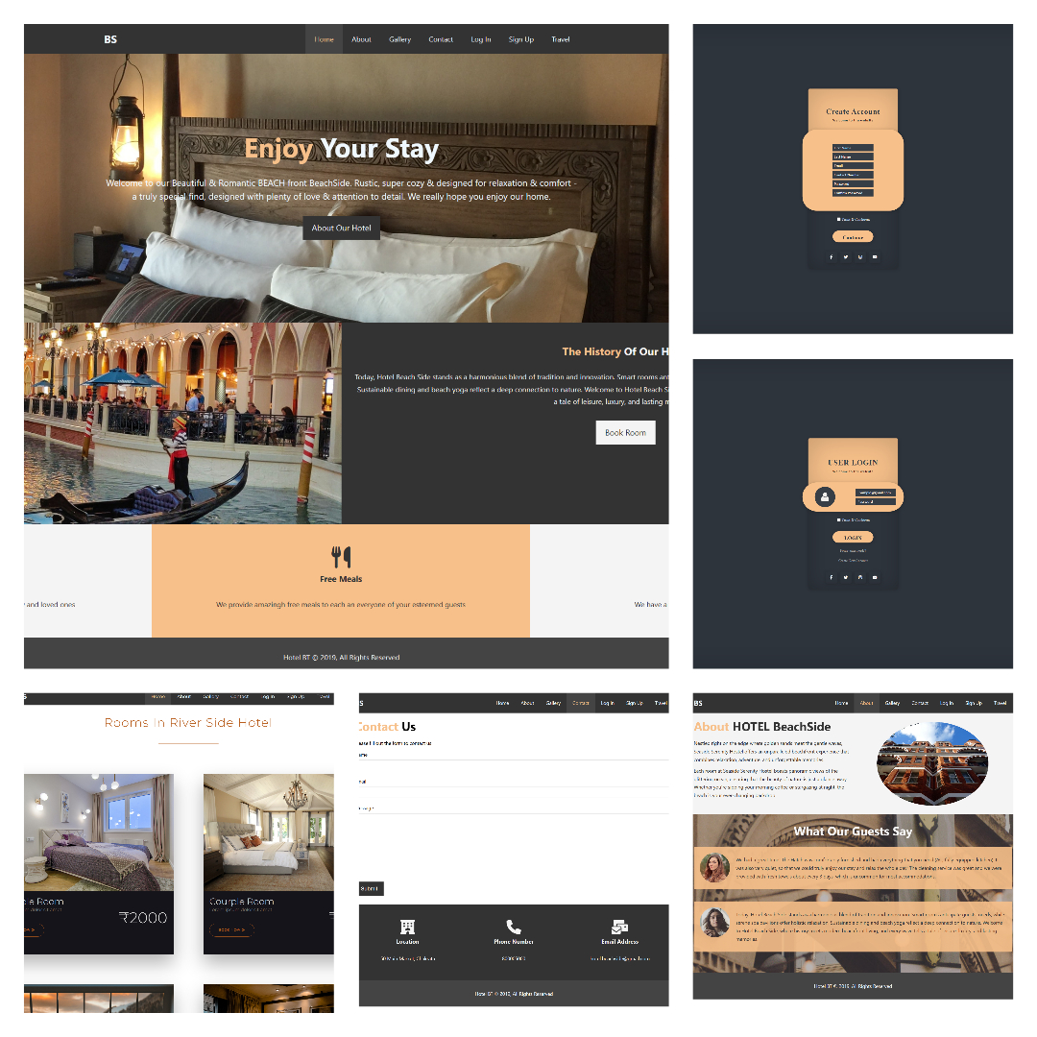

Who doesn’t love to Photograph specially when you are travelling so integrated in our website, we present

Photosnap is a versatile platform designed to empower photographers and visual storytellers to create and share captivating photo stories. With a user-friendly interface and an array of tools, Photosnap simplifies the process of sharing images, crafting narratives, and building connections with a global community of creatives.

I am thrilled to present a comprehensive overview of the Photosnap website, showcasing our dedication to providing a robust platform for photographers and visual storytellers. Our mission revolves around simplifying the process of sharing photos, weaving narratives, and fostering connections. Below, you'll find an in-depth analysis of our website's elements and functionalities:

1. Navigation:

Our website offers an intuitive and seamless user experience. The header menu includes effortless access to several critical sections:

- Home: The homepage, offering an introductory experience.

- Stories: A section that showcases a wide array of user-generated stories.

- Features: A detailed exposition of our platform's capabilities.

- Pricing: An overview of our pricing plans.

- Travel: A link to the travel section, a recommended partner site.

- Get an invite: A prominent call-to-action button facilitating quick registration.

2. The Main Sections:

a. Create and Share Section:

This section encapsulates our core value proposition:

- Heading: A clear and concise heading emphasizing our commitment.

- Description: A brief but compelling description of how we facilitate creating and sharing photo stories.

- Get an invite Link: An easily accessible link inviting users to experience our platform firsthand.

b. Beautiful Stories Section:

In this section, we emphasize the aesthetic appeal of the stories created on Photosnap. Key components include:

- Heading: A captivating heading illustrating our dedication to facilitating beautiful stories.

- Description: A descriptive text explaining the seamless process of creating captivating stories.

- View the stories Link: A direct link to an assortment of user-created stories for immediate exploration.

c. For Everyone Section:

This section reinforces that our platform caters to a diverse audience of photographers, brands, businesses, and more:

- Heading: A clear and inclusive heading, highlighting our universal approach.

- Description: A detailed account of the platform's versatile functionality, suiting users of all levels.

- View the stories Link: Direct access to explore a wide array of stories, displaying the diversity of content.

d. Gallery Section:

The Gallery serves as a visual manifestation of the stories shared on our platform:

- Image Grid: An assortment of images, each functioning as a gateway to an individual user's story.

- Image Names and Author Credits: Engaging image names and author credits to provide context.

- Read Story Links : Quick access to delve into each story in more depth.

3. Features Grid:

The Our Features section highlights the distinctive aspects that set us apart:

- Feature Highlights : Three distinct feature highlights, each paired with an illustrative icon.

- Feature Descriptions : Detailed descriptions elucidating the advantages of our platform, including responsiveness, no upload limits, and embedded media.

- Flexibility Emphasis : A focus on the adaptable nature of our tool, designed for user-friendly navigation and content sharing.

4. Footer:

The footer section encompasses essential information:

- Photosnap Logo: Quick navigation to the homepage, ensuring a consistent and familiar user experience.

- Social Media Links: Links to our social media channels, fostering community engagement and updates.

- Footer Menu: A menu linking to the website's principal sections, for user convenience.

- Get an invite Link: A direct link inviting users to experience our platform firsthand.

- Copyright Information : Copyright and trademark details to protect our brand and intellectual property rights.

Page 2:

1. User-Friendly Header:

- The website's header provides intuitive navigation, enabling easy access to various sections.

- You can explore different segments, such as Home, Stories, Features, and Pricing, with just a click.

2. Captivating Hero Section:

- The hero section serves as a visually striking introduction to the website.

- You'll encounter a featured story that beckons with captivating images, engaging headlines, and author information.

- The hero section is designed to immerse you in the storytelling experience right from the start.

3. Gallery of Visual Delights:

- The heart of Photosnap's creative space resides in the gallery section.

- Here, a diverse collection of photo stories is showcased, each with a compelling image and a succinct introduction.

- Essential information, such as the date of publication and the name of the author, is presented to provide context and depth to the stories.

4. Footer for Connections:

- At the footer of the website, you'll find vital elements to connect with Photosnap.

- This includes links to Photosnap's presence on various social media platforms, facilitating interaction and updates.

- Navigational options are provided to help you explore the site further or request an invite to join the community.

- A copyright notice is included to protect the website's content.

5. Responsive Design:

- Photosnap's website is designed to be fully responsive, ensuring a seamless and enjoyable experience on various devices, from desktop computers to mobile phones.

- The website's design adapts to your screen size, delivering an optimal view and functionality regardless of the device you are using.

6. Stunning Visual Content:

- The website boasts a rich collection of high-quality images and graphics, underlining the importance of visual storytelling.

7. Community Engagement:

- The prominent "Get an invite" button encourages you to become a part of the Photosnap community.

- By joining Photosnap, you gain the ability to share your own stories and connect with other like-minded individuals who share your passion for photography and visual storytelling.

8. Stories Section:

- The Stories section is where you can dive into a curated selection of captivating photo narratives.

- Each story is presented with a title, publication date, and author information, inviting you to explore and experience the stories in more detail.

9. Brand Identity:

- Consistent branding elements, including the logo and color schemes, reinforce the Photosnap brand identity throughout the website.

With its responsive design, captivating content, and interactive features, Photosnap invites you to dive into a world where images and words unite to create immersive narratives. Your journey into the world of visual storytelling begins here. You can start by exploring the website and, if you desire, requesting an invite to join this vibrant community of storytellers. Your storytelling adventure awaits at Photosnap!

Page 3:

The Features page on Photosnap's website is designed to showcase the platform's

unique selling points. It highlights a set of features that set Photosnap apart as an

exceptional tool for visual storytellers. Below is a detailed breakdown of the

features presented on this page:

1. 100% Responsive:

- Photosnap ensures that your stories and content will look stunning and function perfectly on any device, be it a desktop computer, tablet, or smartphone. This feature is vital in today's digital landscape, as people access websites from various devices, and a responsive design guarantees an optimal user experience.

2. No Photo Upload Limit:

- Unlike some platforms that impose restrictions on the number of photos you can upload or the amount of bandwidth you can use, Photosnap allows you to upload photos without any limits. You can freely upload your images in bulk and share all your stories without worrying about constraints.

3. Available to Embed:

- Photosnap goes a step further by offering the ability to embed a wide range of external media in your stories. You can seamlessly include content from platforms like Twitter, Facebook, Instagram, Vimeo, YouTube, Google Maps, and more. This feature enhances your storytelling capabilities, enabling you to create engaging multimedia-rich narratives.

4. Custom Domain:

- With a Photosnap subscription, you can personalize your online presence. This means you can host your stories on your own custom domain, which is a unique web address that reflects your branding or identity. Additionally, you can remove Photosnap's branding, making your stories truly your own.

Page 4:

To create a report based on the content of the webpage you've provided, here's a summary you can present to customers:

Introduction

This report provides an overview of the "Pricing" page on the Photosnap website, designed to help customers understand the pricing structure and features offered.

1. Pricing Hero

- A visually appealing section with a title "Pricing" and a brief description.

- Emphasizes Photosnap as a platform for photographers and visual storytellers.

2. Pricing Tabs

- Customers can choose between monthly and yearly plans using a toggle switch.

- Three pricing tiers are presented: Basic, Pro, and Business.

- Each tier includes a description, pricing in both monthly and yearly formats, and a "Pick Plan" button.

3. Compare Section

- Provides a comparison table of features across the three pricing tiers.

- Highlights features such as unlimited story posting, unlimited photo uploads, custom content embedding, and more.

- Clearly shows which features are available in each plan.

4. Beta Section

- Informs users that the platform is in beta and invites them to request an invite.

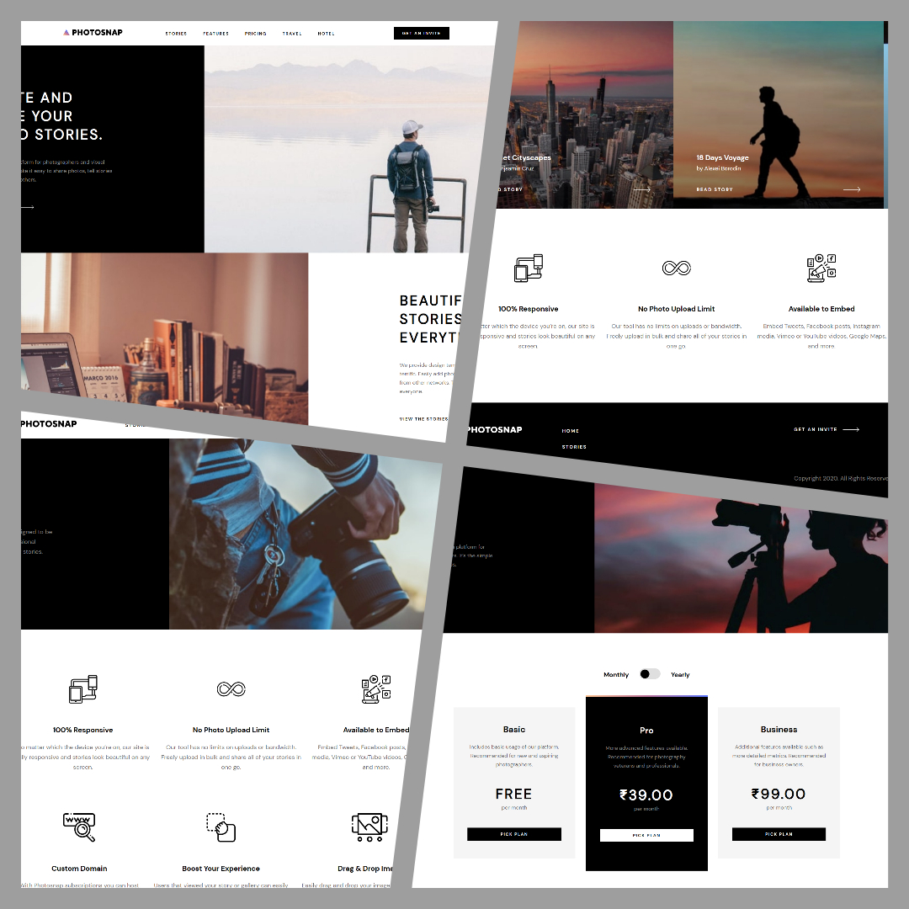

Footer Section

The footer includes links to the homepage and other important pages, social media links, and copyright information. It also offers another opportunity to "Get an invite."

I have Created Total of 21 Webpages